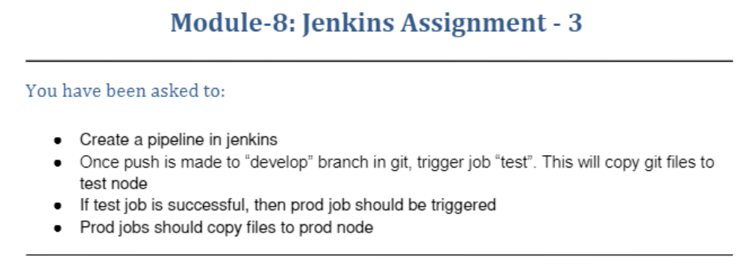
Pipeline created in Jenkins master

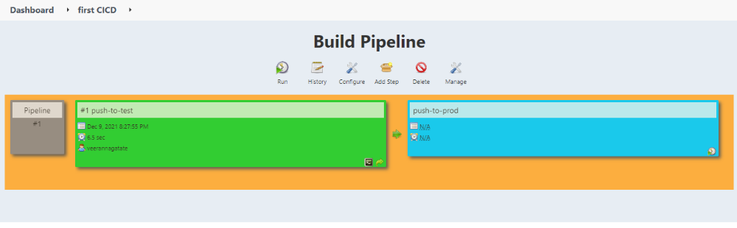

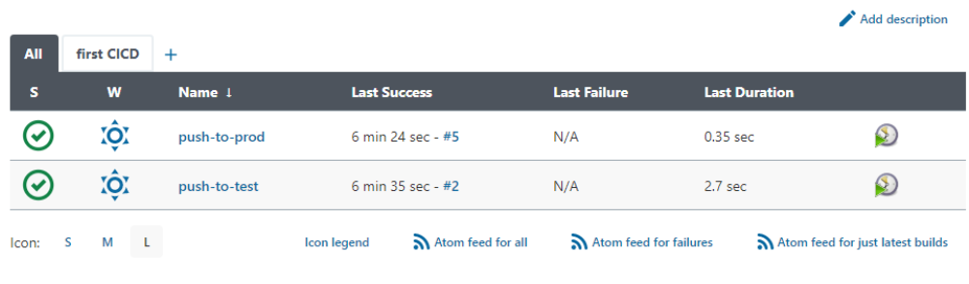

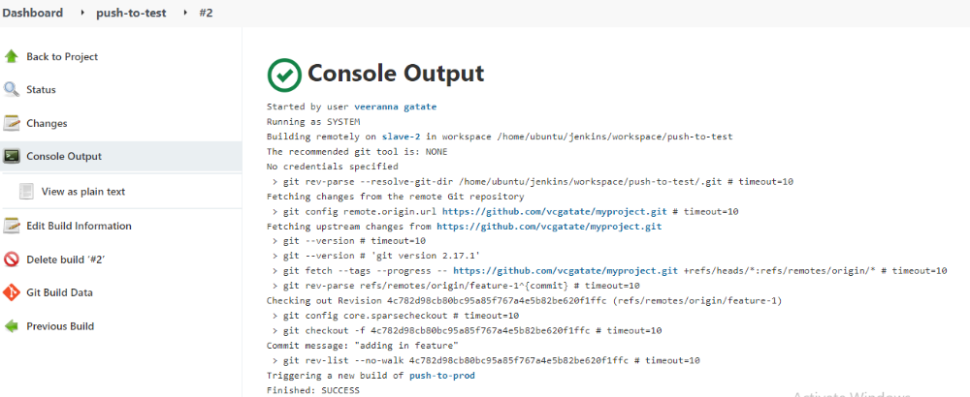

ubuntu@ip-172-31-30-0:~$ cd jenkins/
ubuntu@ip-172-31-30-0:~/jenkins$ ls
remoting workspace
ubuntu@ip-172-31-30-0:~/jenkins$ cd workspace/
ubuntu@ip-172-31-30-0:~/jenkins/workspace$ ls
push-to-test
ubuntu@ip-172-31-30-0:~/jenkins/workspace$ cd push-to-test/
ubuntu@ip-172-31-30-0:~/jenkins/workspace/push-to-test$ ls
3.txt 4.txt 5.txt 6.txt config.json main.java
ubuntu@ip-172-31-30-0:~/jenkins/workspace/push-to-test$ cat main.java
this is a sample Java
ubuntu@ip-172-31-30-0:~/jenkins/workspace/push-to-test$

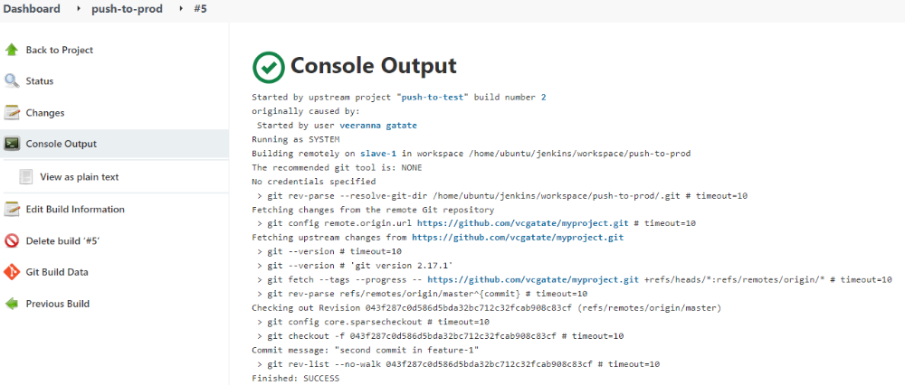

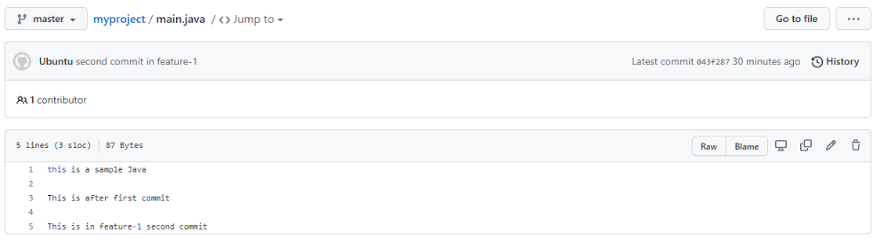
ubuntu@ip-172-31-30-81:~$ cd jenkins/
ubuntu@ip-172-31-30-81:~/jenkins$ cd workspace/
ubuntu@ip-172-31-30-81:~/jenkins/workspace$ ls
Git-job push-to-prod
ubuntu@ip-172-31-30-81:~/jenkins/workspace$ cd push-to-prod/
ubuntu@ip-172-31-30-81:~/jenkins/workspace/push-to-prod$ ls
3.txt 4.txt 5.txt config.json main.java
ubuntu@ip-172-31-30-81:~/jenkins/workspace/push-to-prod$ cat main.java
this is a sample Java

This is after first commit

This is in feature-1 second commit
ubuntu@ip-172-31-30-81:~/jenkins/workspace/push-to-prod$

